**Problema 1000**

import java.io.IOException;

public class Main {

public static void main(String[] args) throws IOException {

System.out.println("Hello World!");

}

}

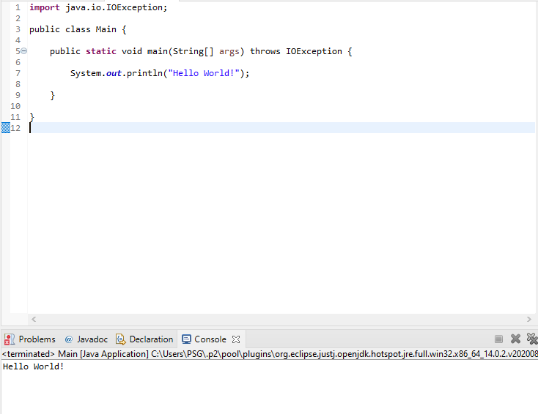

**Problema 1001**

import java.io.IOException;

import java.util.Scanner;

public class Main {

public static void main(String[] args) throws IOException {

Scanner sc = new Scanner(System.in);

int a = sc.nextInt();

int b = sc.nextInt();

int x = a + b;

System.out.println("X = " + x);

}

}

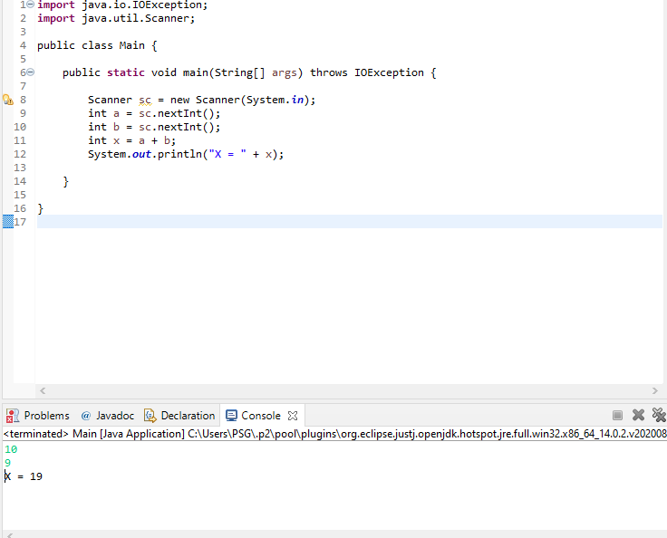

**Problema 1002**

import java.io.IOException;

import java.util.Scanner;

public class Main {

public static void main(String[] args) throws IOException {

Scanner sc = new Scanner(System.in);

double raio = sc.nextDouble();

double n = 3.14159;

double raioQuadrado = Math.pow(raio, 2);

double area = n * raioQuadrado;

System.out.println("A=" + String.format("%.4f", area));

}

}

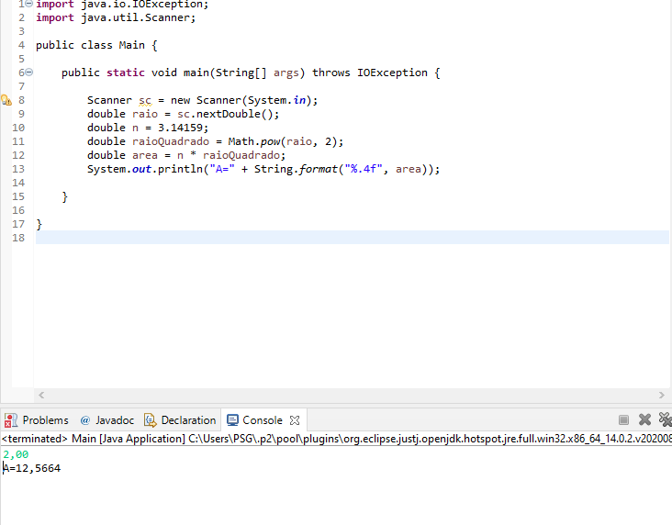

**Problema 1003**

import java.io.IOException;

import java.util.Scanner;

public class Main {

public static void main(String[] args) throws IOException {

Scanner sc = new Scanner(System.in);

int a = sc.nextInt();

int b = sc.nextInt();

int soma = a + b;

System.out.println("SOMA = " + soma);

}

}

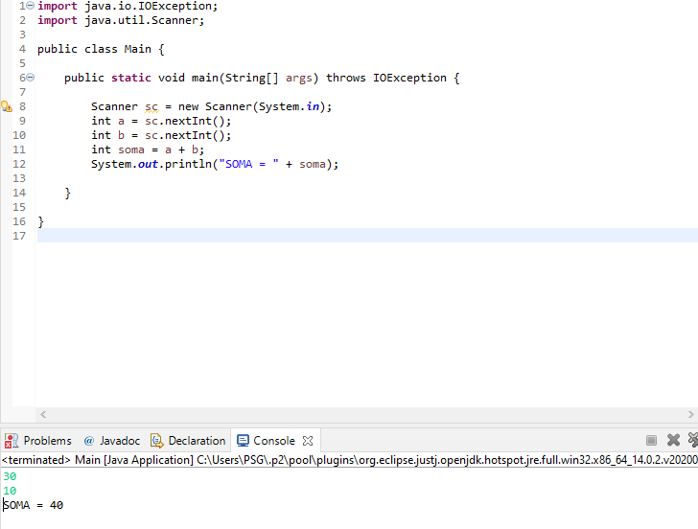

**Problema 1004**

import java.io.IOException;

import java.util.Scanner;

public class Main {

public static void main(String[] args) throws IOException {

Scanner sc = new Scanner(System.in);

int a = sc.nextInt();

int b = sc.nextInt();

int prod = a * b;

System.out.println("PROD = " + prod);

}

}

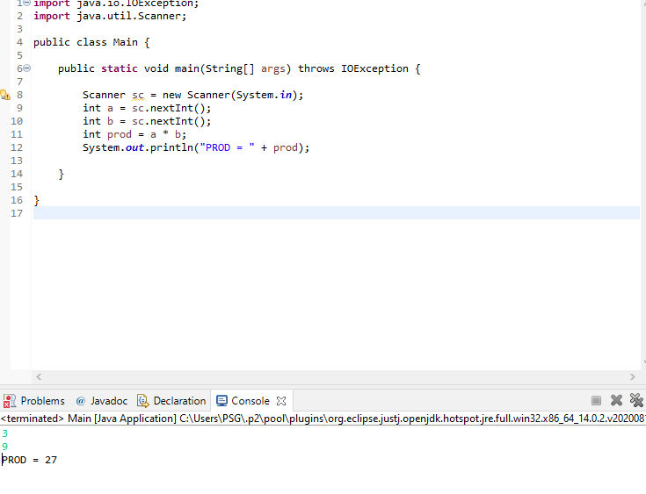

**Problema 1005**

import java.io.IOException;

import java.util.Scanner;

public class Main {

public static void main(String[] args) throws IOException {

Scanner sc = new Scanner(System.in);

double a = sc.nextDouble();

double b = sc.nextDouble();

double media = (a * 3.5 + b * 7.5) / 11;

System.out.println("MEDIA = " + String.format("%.5f", media));

}

}

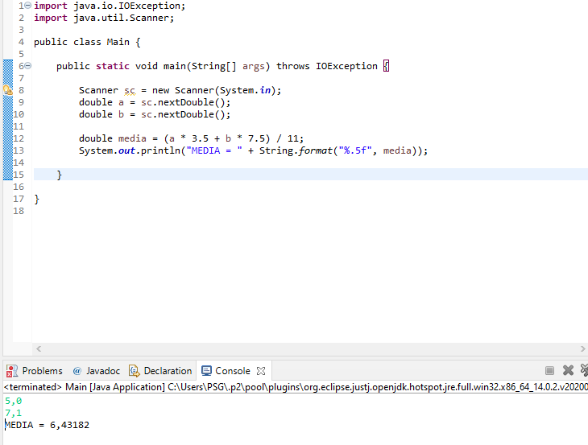

**Problema 1006**

import java.io.IOException;

import java.util.Scanner;

public class Main {

public static void main(String[] args) throws IOException {

Scanner sc = new Scanner(System.in);

double a = sc.nextDouble();

double b = sc.nextDouble();

double c = sc.nextDouble();

double media = (a * 2 + b * 3 + c * 5) / 10;

System.out.println("MEDIA = " + String.format("%.1f", media));

}

}

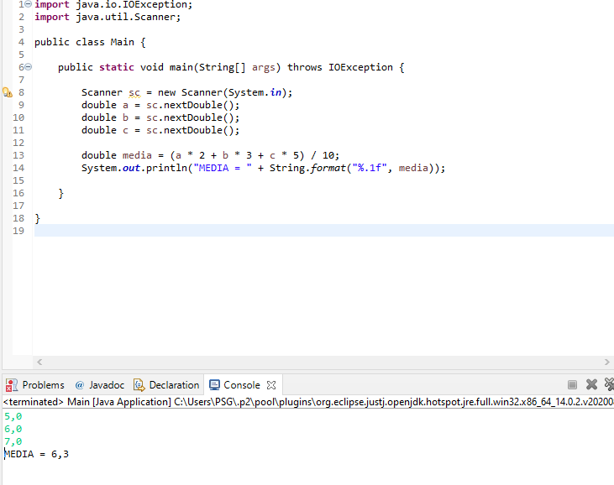

**Problema 1007**

import java.io.IOException;

import java.util.Scanner;

public class Main {

public static void main(String[] args) throws IOException {

Scanner sc = new Scanner(System.in);

int a = sc.nextInt();

int b = sc.nextInt();

int c = sc.nextInt();

int d = sc.nextInt();

int diferenca = a * b - c * d;

System.out.println("DIFERENCA = " + diferenca);

}

}

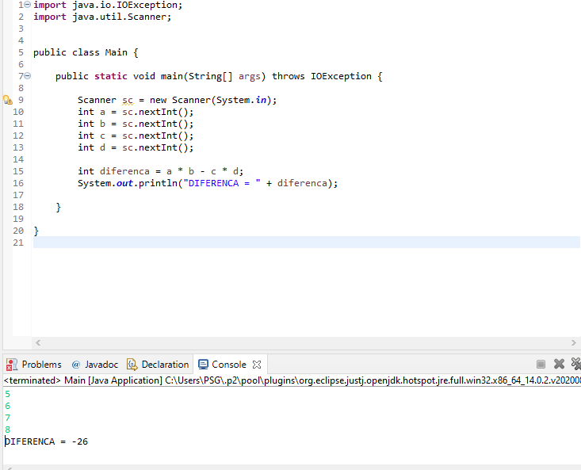

**Problema 1008**

import java.io.IOException;

import java.util.Scanner;

public class Main {

public static void main(String[] args) throws IOException {

Scanner sc = new Scanner(System.in);

int numero = sc.nextInt();

int horas = sc.nextInt();

double horasTrabalhadas = sc.nextDouble();

double salario = horas * horasTrabalhadas;

System.out.println("NUMBER = " + numero);

System.out.println("SALARY = U$ " + String.format("%.2f", salario));

}

}

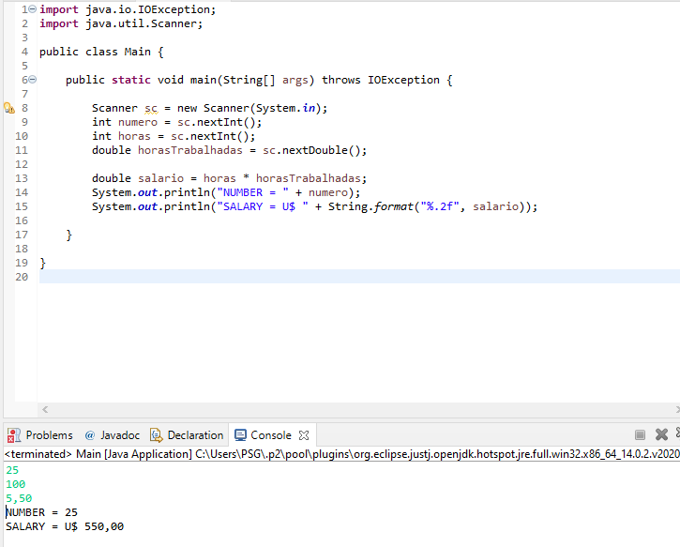

**Problema 1009**

import java.io.IOException;

import java.util.Scanner;

public class Main {

public static void main(String[] args) throws IOException {

Scanner sc = new Scanner(System.in);

String nome = sc.next();

double salarioFixo = sc.nextDouble();

double vendas = sc.nextDouble();

double salario = salarioFixo + vendas * 0.15;

System.out.println("TOTAL = R$ " + String.format("%.2f", salario));

}

}

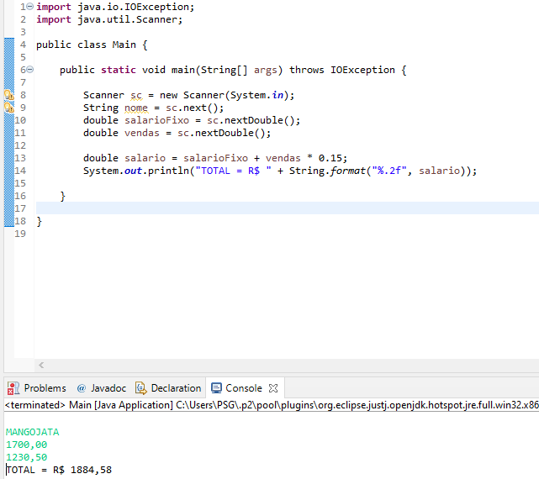

**Problema 1010**

import java.io.IOException;

import java.util.Scanner;

public class Main {

public static void main(String[] args) throws IOException {

Scanner sc = new Scanner(System.in);

int codigo1 = sc.nextInt();

int quantidade1 = sc.nextInt();

double valor1 = sc.nextDouble();

int codigo2 = sc.nextInt();

int quantidade2 = sc.nextInt();

double valor2 = sc.nextDouble();

double valorTotal = quantidade1 * valor1 + quantidade2 * valor2;

System.out.println("VALOR A PAGAR: R$ " + String.format("%.2f", valorTotal));

}

}

